Booking a course at ALSG

Please be aware that you will be asked to make a payment during the booking process. Your course place will be cancelled if you have not made the payment within 24 hours of reserving your course place.

If you already have a profile on the VLE
- please log in at www.alsg.org/vle

If you do not have a profile on the VLE
- please create a profile at http://www.alsg.org/vle/login/signup.php
Booking a course place
- Click on ‘Book and pay for an ALSG, Manchester course’ on the right of the page, then click on the link for the course you would like to book:
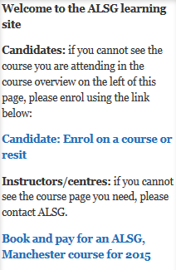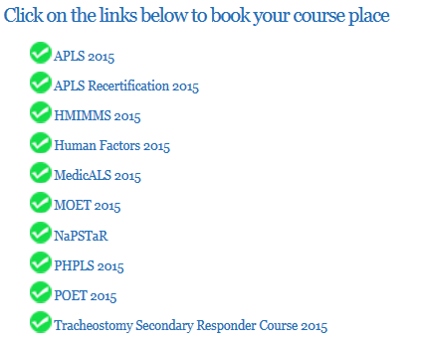

- Once you have chosen your course, you will receive a booking email with a link to your course page.
- Follow the instructions in this email to pay via PayPal and follow the PayPal process through.
- After payment, please follow the PayPal instructions to your course page (do not close down the PayPal window until you have entered your course page).
- Enjoy your course.

