APEx Handouts - Faculty

Contents
APEx FACULTY HANDOUTS 1
Session 1_Securing safety key points 3
Notes from original slide set 3
Session 2_De-escalation key points 6
De-escalation flowchart 8
8
Session 3_Confusion key points 9

NB – See the Candidate Handouts for additional materials which are available to both groups

Session 1_Securing safety key points

Notes from original slide set
This seems obvious but you’ll find that most emergency department staff have no training in the safe restraining of patients.

Use all the information available, this may be from relatives, paramedics/ambulance service. They may well have risked assess the patient already.
Even if you think a patient does not pose a risk it is good practice to at least inform others. If they are high risk be patient and ensure you have the right staff members remember the previous slide.

The Royal College of Psychiatrists has some guidance on the standards of safety rooms and most departments will have an appropriate room but not always.

Always have a plan in case the patient suddenly becomes aggressive and should be part of the preparation to see the patient.

Containment – staff requirement
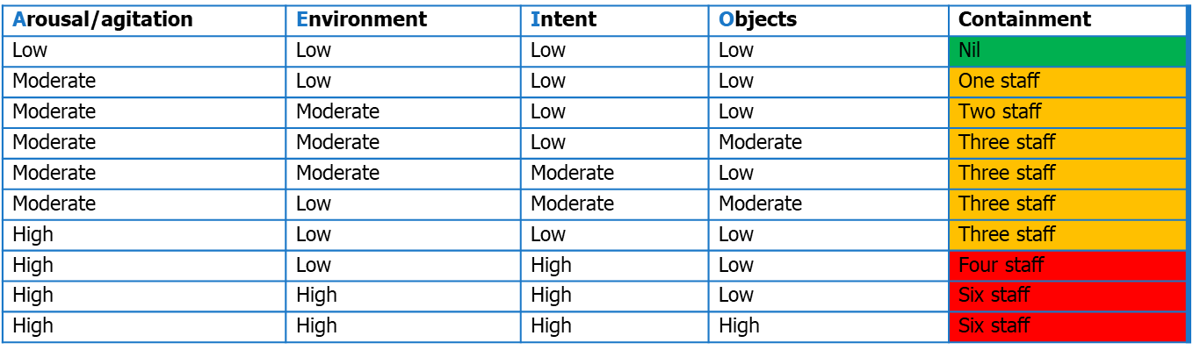

There are no clear guidance about the staffing needed to manage and safely contain acutely disturbed patients. Patients in the red who you can’t verbally deescalate and calm down will more often than not need rapid tranquilisation.

With all this in mind what things can you do when you are actually seeing a disturbed patient?

It seems simple but telling a patient your name and that you are a doctor there to help them may in some cases deescalate the situations as these patient are often very scared

Session 2_De-escalation key points

Notes from original slide set

See full algorithm below:

De-escalation flowchart

Session 3_Confusion key points

Notes from original slide set

